***Susan Le Roux*** +61 415 735 587 [info@champagnegoddess.com.au](mailto:info@champagnegoddess.com.au) [www.champagnegoddess.com.au](http://www.champagnegoddess.com.au)

Susan Le Roux – the Champagne Goddess is regularly engaged to deliver inspiring and educational Masterclasses ; Events and Wine-Tastings.

Event ideas

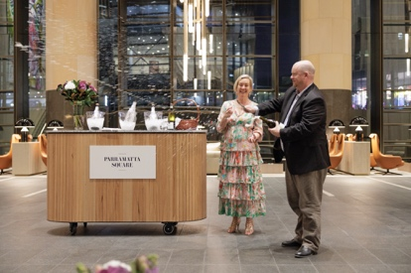 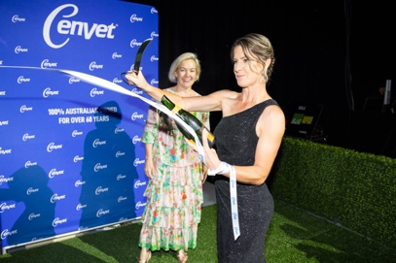 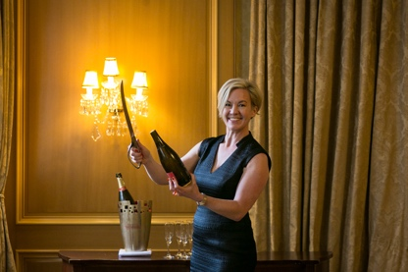 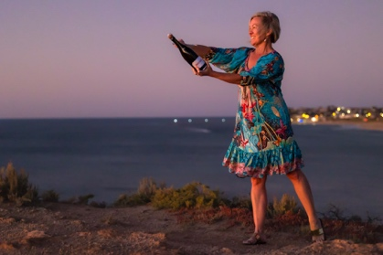

**#1: The Art of Sabrage**

Let Susan share the limelight with several key clients or members of your team; who are willing to (safely) learn ‘the Art of Sabrage’. With expert Tutorage, your guests will slice the top off a bottle of champagne, a-la Napoleon Bonaparte in the early 1800’s…

There’s an opportunity to add a Champagne or Sparkling Wine Master-class or Blind-tasting. Costs from $1,200 +gst

Request a quote: opt-in champagne; glassware; tasting notes; certificates and/or small gift-boxes for the cork.

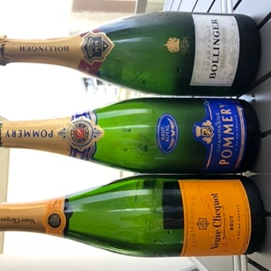 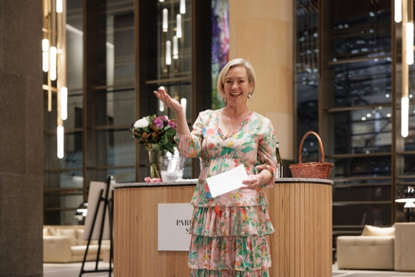 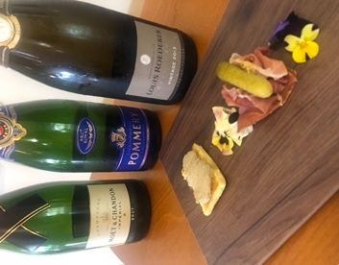 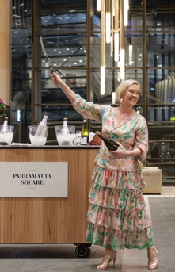

**#2: 'Les Veuves de Champagne' – How the Widows of the Champagne region saved their industry through the ages.**

Designed as an intimate, educational and seated Masterclass for up to 21 guests; we will taste, compare and discuss the differences between three famous Grand Maisons de Champagne; while learning the history of the Houses and the almost insurmountable obstacles the Widows of Champagne triumphed over.

From $1,500 +gst + champagnes. Audio Visual Presentation available.

**#3: The impact of WAR on Champagne and how we know it.**

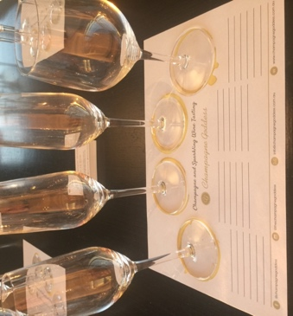 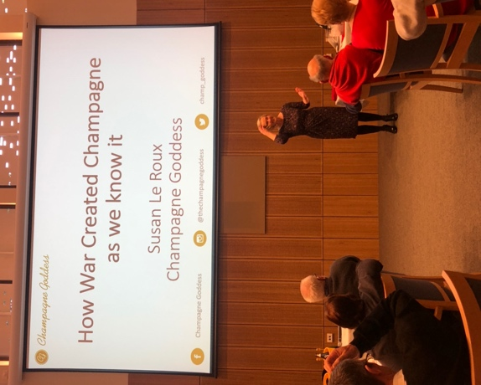 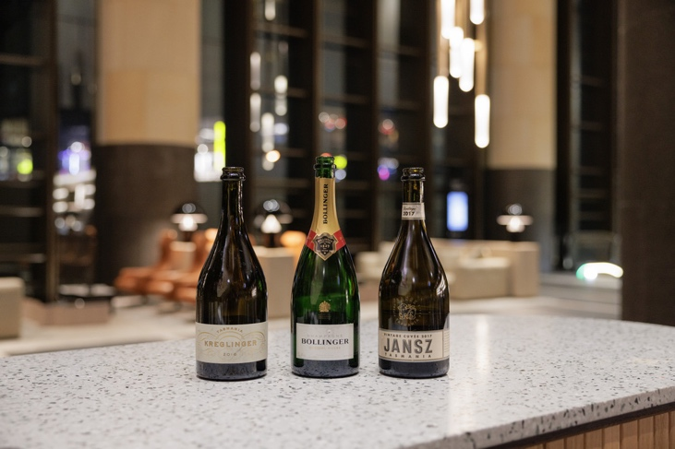 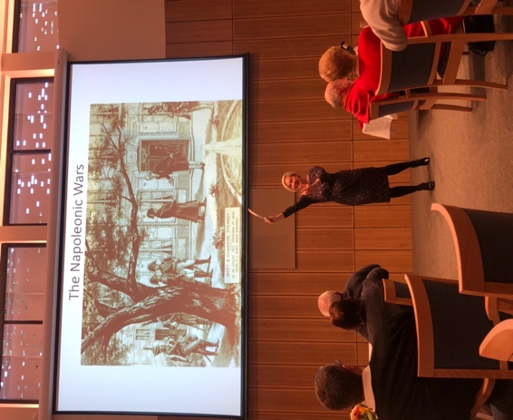

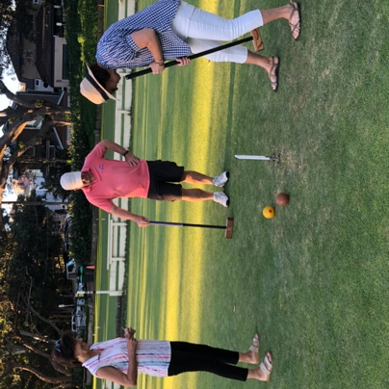 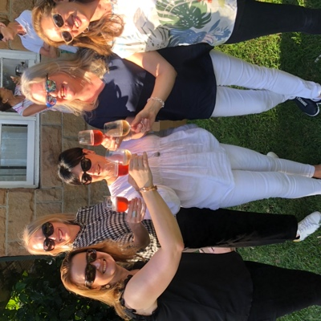 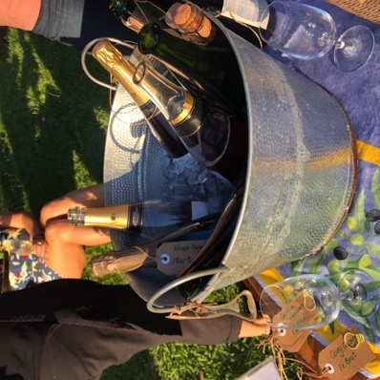 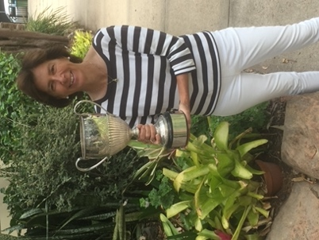

**#3: Croquet + Champagne**

The Champagne Goddess, together with Australia’s Open Croquet Champion Alison Sharpe invite you to get outdoors and learn the technical game of Croquet. With night-time opportunity at Cammeray; or an afternoon of sunshine in Coogee, Sydney, start with two, and increase to four different champagnes, sparkling wines or proseccos; plus instruction in the game of Croquet. Based on 12-21 guests, costs from $120pp.



*‘Bringing the magic of Champagne alive’*