

**Sparkling Wine Tour - Tasmania 2024**

**Tamar Valley – 6 to 10 November, 2024**

**~ incorporating Effervescence Tasmania 9 + 10 November, 2024 ~**

Dear Champagne and Sparkling Wine *Goddesses (+ Gods)*

This year’s ‘Goddess Sparkling Wine Tour to Tasmania’ is now open for bookings, and I’d like to offer you very special *early-pricing*.

*This year is going to be* *magical…* Not only will we participate in the absolute highlights of Effervescence Festival, we will also expand our sparkling wine knowledge, understanding and experience with up-close and personal visits to Tasmania’s most admired and award-winning vineyards.

From Wednesday the 6th to Friday 8th November I will take you on a spellbinding tour of the Tamar Valley in north-eastern Tasmania; and we will finish the week with the glamour of the best of Tasmania’s Sparkling Wine Festival [Effervescence Tasmania](http://www.effervescencetasmania.com) 2024 at Josef Chromy winery.

*Take advantage of the Early Pricing:* ***special rate of $2,997 per person until 15 September 24***

***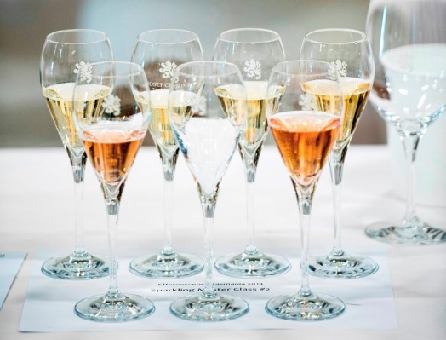****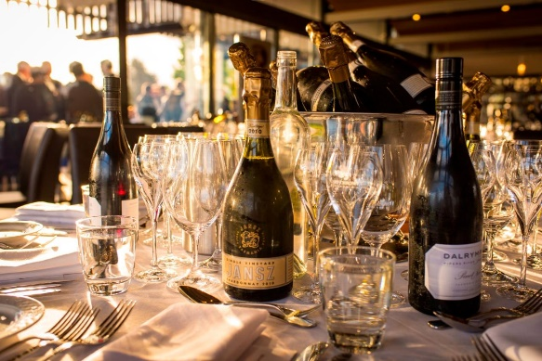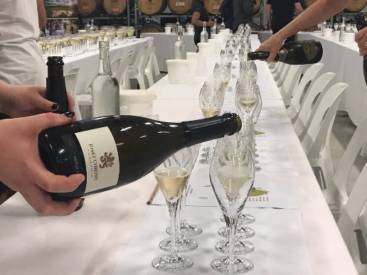 Fill-in page 2, scan+return, send the deposit, and I will ensure Effervescence holds our tickets!*

Inclusions:

* Arrival airport transfers (after 8pm) Tuesday 5th or Wednesday 6th November 2024.
* 4 nights elegant accommodation at the brand new ‘Change Overnight Philanthropic Apartments’ in Launceston – 2-bedroon apartments –King, twin and triple rooms available – please indicate a preference
* Wednesday, Thursday and Friday full-days of sparkling (and still) wine tasting experiences, a walking tour to Cataract Gorge + High Tea, a light lunch and some free-time.
* Visits to Tamar Valley wineries, with private, unique sparkling wine-tasting experiences at:
  + **BelleBonne** - with the Queen of Sparkling Rosé the inspirational Natalie Fryar;
  + Andrew Pirie – considered ‘the pioneer of the Tasmanian Wine industry’ and his winery **Apogee**;
  + Winemaker Fran Austin’s **Delamere Vineyard**, with her husband Shane Holloway;
  + **Holm Oak**’s winemaker Bec Duffy - and her husband Tim Duffy;
  + Ed Carr of **House of Arras** and Stewart Byrne of **Bay of Fires**; + *more to be confirmed*…
* An exclusive, private luncheon with the amazing **Natalie Fryar – Australia’s Queen of Sparkling Rosé** and one of Australia’s most decorated sparkling wine makers. After 14 years as the chief winemaker at Jansz, she now creates in incomparable BelleBonne sparkling wines. The exceptional restaurant ***Evenfall*** at BelleBonne’s new Cellar Door’s will welcome us on Wednesday 6th November.
* Lunch and foodie experiences at the wineries; plus a casual dinner Thursday night.
* Friday morning – transport to the famous Cataract Gorge for a walk, peacocks and Devonshire High Tea.
* A stroll around Launceston’s **Harvest** **Markets** on Saturday – before Effervescence’s Grand Tasting.

Also includes the following Effervescence experiences:

* + **Friday 8 November** 6:00pm - Black Tie 5-course Degustation Dinner at Josef Chromy winery, and hosted by a Tasmanian Sparkling Wine House (Effervescence pricing is $275.00pp)
  + **Saturday 9 November** 11:00am - The Grand Tasting: showcasing 15 of Tasmania’s finest sparkling wine makers, so you can meet the creators of your favourite sparklings.
  + **Saturday 9 November** 11:30am - **Tasmanian Masterclass** – an incredible line-up – a must-do.
  + **Saturday 9 November** 1:30pm - **International Masterclass** Taste and compare three to four flights of sparkling wines from the New World against vintage, grower and unique *Champagnes*
  + **Saturday 9 November** from 5:30pm **Bubbles & Beats** After Party. Relax after a long day of tastings with some tunes, some dancing, light food and craft beer at Josef Chromy Winery*
  + *food options (Food trucks + Coffee van) will be available to purchase during the event at Josef Chromy Winery.
* The whole tour includes luxury private transport – driven by Susan Le Roux: Tuesday evening / Wednesday morning arrival transfers from Launceston Airport; Winery Touring on Wednesday, Thursday and Friday; Transport to and from dinner Thursday + Friday night (Gala Dinner); Saturday transport to Josef Chromy Winery (please note: Susan not attending Saturday night🡪 own return transfer-via taxi)

**Early-pricing of $2,997 per person, twin-share; 2-bedroom apartments – available till 15 September**

Please indicate whether you’d like Susan to secure *additional* [Effervescence Tasmania](http://www.effervescencetasmania.com/) options:

1. **Sunday 10 November** - **BelleBonne Gastronomy Experience** featuring museum wines and new releases of BelleBonne’s sparkling wines and Wellington & Wolf’s incredible Rieslings and still wines. At their new Cellar Door + Restaurant: ‘Evenfall’ @ *$310pp +booking fee + own transport*
2. **Sunday 10 November – House of Arras** - at the House of Arras Cellar Door in Pipers River. A unique winery experience commencing with a Masterclass at 10am, 12noon or 2pm, followed by a brief vineyard tour and a sampling of a specially matured cheese with one of their signature EJ Carr Late Disgorged wines. @ *$120pp +booking fee + own transport*
3. **Sunday 10 November – Let’s Jansz** – at Jansz Winery – An enjoyable day out filled with live music, local fresh oysters or cheese plates, a glass or Jansz Tasmania Sparkling Brut or Rosé. @ *$40pp +bkg fee +own transport*

***Secure your place in this year’s personalised ‘Goddess Tour to Tasmania’ by returning the Page 2 form – also downloadable- by 15 September 2024 with a refundable* deposit of $1,000 AUD.***

*After 15 September the per person price will be $3,397pp*